Hasil practical-test response API

e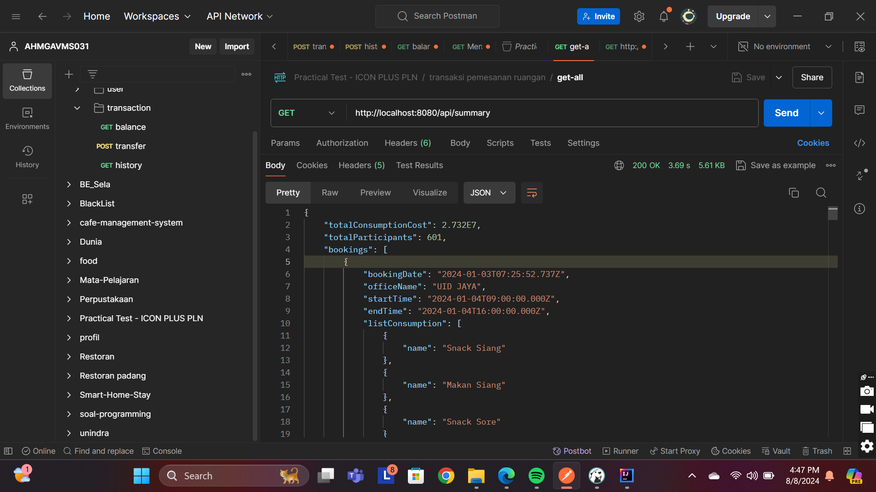Tugas yaitu membuat API summary dari pemesanan ruangan yang akan dipakai pada halaman Dashboard berdasarkan data transaksi pemesanan ruangan yang ada  
endpoint : <http://localhost:8080/api/summary>responsebody :   
 {

"totalConsumptionCost": 2.732E7,

"totalParticipants": 601,

"bookings": [

{

"bookingDate": "2024-01-03T07:25:52.737Z",

"officeName": "UID JAYA",

"startTime": "2024-01-04T09:00:00.000Z",

"endTime": "2024-01-04T16:00:00.000Z",

"listConsumption": [

{

"name": "Snack Siang"

},

{

"name": "Makan Siang"

},

{

"name": "Snack Sore"

}

],

"participants": 62,

"roomName": "Ruang Borobudur",

"id": "1"

},

{

"bookingDate": "2024-01-03T08:25:52.737Z",

"officeName": "UID JAYA",

"startTime": "2024-01-04T09:00:00.000Z",

"endTime": "2024-01-04T14:00:00.000Z",

"listConsumption": [

{

"name": "Snack Siang"

},

{

"name": "Makan Siang"

}

],

"participants": 42,

"roomName": "Ruang Prambanan",

"id": "2"

},

{

"bookingDate": "2024-01-03T08:25:52.737Z",

"officeName": "UID JAYA",

"startTime": "2024-01-04T09:00:00.000Z",

"endTime": "2024-01-04T11:00:00.000Z",

"listConsumption": [

{

"name": "Snack Siang"

}

],

"participants": 15,

"roomName": "Ruang Mendhut",

"id": "3"

},

{

"bookingDate": "2024-01-03T08:25:52.737Z",

"officeName": "UID JAYA",

"startTime": "2024-01-04T13:00:00.000Z",

"endTime": "2024-01-04T16:00:00.000Z",

"listConsumption": [

{

"name": "Makan Siang"

},

{

"name": "Snack Sore"

}

],

"participants": 27,

"roomName": "Ruang Mendhut",

"id": "4"

},

{

"bookingDate": "2024-01-06T08:25:52.737Z",

"officeName": "UID JABAR",

"startTime": "2024-01-08T13:00:00.000Z",

"endTime": "2024-01-08T16:00:00.000Z",

"listConsumption": [

{

"name": "Makan Siang"

},

{

"name": "Snack Sore"

}

],

"participants": 27,

"roomName": "Ruang Rinjani",

"id": "5"

},

{

"bookingDate": "2024-01-05T08:25:52.737Z",

"officeName": "UID BALI",

"startTime": "2024-01-07T09:00:00.000Z",

"endTime": "2024-01-07T11:00:00.000Z",

"listConsumption": [

{

"name": "Snack Siang"

}

],

"participants": 27,

"roomName": "Ruang Ganesha",

"id": "6"

},

{

"bookingDate": "2024-01-08T08:25:52.737Z",

"officeName": "UID JAYA",

"startTime": "2024-01-10T09:00:00.000Z",

"endTime": "2024-01-10T16:00:00.000Z",

"listConsumption": [

{

"name": "Snack Siang"

},

{

"name": "Makan Siang"

},

{

"name": "Snack Sore"

}

],

"participants": 30,

"roomName": "Ruang Prambanan",

"id": "7"

},

{

"bookingDate": "2024-01-01T08:00:52.737Z",

"officeName": "UID JATENG & DIY",

"startTime": "2024-01-03T09:00:00.000Z",

"endTime": "2024-01-03T14:00:00.000Z",

"listConsumption": [

{

"name": "Snack Siang"

},

{

"name": "Makan Siang"

}

],

"participants": 35,

"roomName": "Ruang Arjuna",

"id": "8"

},

{

"bookingDate": "2024-01-05T09:25:52.737Z",

"officeName": "UID JAYA",

"startTime": "2024-01-06T14:00:00.000Z",

"endTime": "2024-01-06T16:00:00.000Z",

"listConsumption": [

{

"name": "Snack Sore"

}

],

"participants": 40,

"roomName": "Ruang Borobudur",

"id": "9"

},

{

"bookingDate": "2024-01-15T09:25:52.737Z",

"officeName": "UID JAYA",

"startTime": "2024-01-17T08:00:00.000Z",

"endTime": "2024-01-17T11:00:00.000Z",

"listConsumption": [

{

"name": "Snack Siang"

}

],

"participants": 40,

"roomName": "Ruang Borobudur",

"id": "10"

},

{

"bookingDate": "2024-01-02T08:30:52.737Z",

"officeName": "UID JATIM",

"startTime": "2024-01-05T08:00:00.000Z",

"endTime": "2024-01-05T11:00:00.000Z",

"listConsumption": [

{

"name": "Snack Siang"

}

],

"participants": 23,

"roomName": "Ruang Sudirman",

"id": "11"

},

{

"bookingDate": "2024-01-03T09:30:52.737Z",

"officeName": "UID JATIM",

"startTime": "2024-01-05T08:00:00.000Z",

"endTime": "2024-01-05T11:00:00.000Z",

"listConsumption": [

{

"name": "Snack Siang"

}

],

"participants": 30,

"roomName": "Ruang Fatmawati",

"id": "12"

},

{

"bookingDate": "2024-01-11T09:30:52.737Z",

"officeName": "UID JATIM",

"startTime": "2024-01-13T09:00:00.000Z",

"endTime": "2024-01-13T16:00:00.000Z",

"listConsumption": [

{

"name": "Snack Siang"

},

{

"name": "Makan Siang"

},

{

"name": "Snack Sore"

}

],

"participants": 25,

"roomName": "Ruang Fatmawati",

"id": "13"

},

{

"bookingDate": "2024-01-15T09:30:52.737Z",

"officeName": "UID JATIM",

"startTime": "2024-01-18T09:00:00.000Z",

"endTime": "2024-01-18T16:00:00.000Z",

"listConsumption": [

{

"name": "Snack Siang"

},

{

"name": "Makan Siang"

},

{

"name": "Snack Sore"

}

],

"participants": 23,

"roomName": "Ruang Sudirman",

"id": "14"

},

{

"bookingDate": "2024-01-04T09:30:52.737Z",

"officeName": "UID JABAR",

"startTime": "2024-01-07T09:00:00.000Z",

"endTime": "2024-01-07T16:00:00.000Z",

"listConsumption": [

{

"name": "Snack Siang"

},

{

"name": "Makan Siang"

},

{

"name": "Snack Sore"

}

],

"participants": 23,

"roomName": "Ruang Galunggung",

"id": "15"

},

{

"bookingDate": "2024-01-04T10:30:52.737Z",

"officeName": "UID JABAR",

"startTime": "2024-01-08T09:00:00.000Z",

"endTime": "2024-01-08T14:00:00.000Z",

"listConsumption": [

{

"name": "Snack Siang"

},

{

"name": "Makan Siang"

}

],

"participants": 20,

"roomName": "Ruang Semeru",

"id": "16"

},

{

"bookingDate": "2024-01-04T10:30:52.737Z",

"officeName": "UID JABAR",

"startTime": "2024-01-08T15:00:00.000Z",

"endTime": "2024-01-08T17:00:00.000Z",

"listConsumption": [

{

"name": "Snack Sore"

}

],

"participants": 18,

"roomName": "Ruang Semeru",

"id": "17"

},

{

"bookingDate": "2024-01-10T08:30:52.737Z",

"officeName": "UID JABAR",

"startTime": "2024-01-13T15:00:00.000Z",

"endTime": "2024-01-13T17:00:00.000Z",

"listConsumption": [

{

"name": "Snack Sore"

}

],

"participants": 20,

"roomName": "Ruang Semeru",

"id": "18"

},

{

"bookingDate": "2024-01-15T08:30:52.737Z",

"officeName": "UID JABAR",

"startTime": "2024-01-17T09:00:00.000Z",

"endTime": "2024-01-17T16:00:00.000Z",

"listConsumption": [

{

"name": "Snack Siang"

},

{

"name": "Makan Siang"

},

{

"name": "Snack Sore"

}

],

"participants": 20,

"roomName": "Ruang Bromo",

"id": "19"

},

{

"bookingDate": "2024-01-05T08:45:52.737Z",

"officeName": "UID BALI",

"startTime": "2024-01-08T09:00:00.000Z",

"endTime": "2024-01-08T14:00:00.000Z",

"listConsumption": [

{

"name": "Snack Siang"

},

{

"name": "Makan Siang"

}

],

"participants": 27,

"roomName": "Ruang Ganesha",

"id": "20"

},

{

"bookingDate": "2024-01-10T08:45:52.737Z",

"officeName": "UID BALI",

"startTime": "2024-01-12T09:00:00.000Z",

"endTime": "2024-01-12T14:00:00.000Z",

"listConsumption": [

{

"name": "Snack Siang"

},

{

"name": "Makan Siang"

}

],

"participants": 27,

"roomName": "Ruang Ganesha",

"id": "21"

}

]

}